**Object Detection using Machine Learning**

A project Report

Submitted to

Dr.D.Subbulekshmi

Submitted by

**Student name: -** **Reg no: -**

Tanya 19BEE1199

Shashank Sridhar 19BCE1429

Kamal Kant Yadav 19BEE1149

Shrisrinivas P 19BEE1055

**EEE 1007 – Neural Networks and Fuzzy Control**



April 2022

**Contents**

| **S.No** | **Chapter Title** | **Page No.** |
| --- | --- | --- |
| 1 | Abstract | 2 |
| 3 | Chapter-2 | 3 |
| 4 | Chapter-3 | 4 |
| 5 | Chapter-4 | 5 |
| 6 | Chapter-5 | 5 |
| 7 | Reference | 6 |

**Abstract**

In recent years, object detection using Machine learning technique has gained numerous of attention round the world. Main usage of object detection can be seen in the field of autonomous vehicles, Field of AI associated with good medical diagnostics. The main goal of this project is to develop a methodology which detects objects supporting the scale dimensions that are given as an input to the system through a dataset in python idle. System will be drawing bounding rectangles for the object during the process of object detection. Python Programming and a Machine Learning Technique named SSD algorithm is deployed during this project for objective recognition. The Tensor Flow Object Detection API lets in effective deep gaining knowledge of hopped-up item detection versions whose overall performance is really good. Tensor Flow even affords many pre-skilled version architectures with enclosed weights skilled at the coco palm dataset.

**Chapter 1**

**Introduction about your Project**

Object detection is the challenge of detecting times of items of a positive magnificence inside a picture. Achieving greater heights in object recognition and picture category became feasible due to Convolution Neural Network (CNN). However, in comparison to the picture category the object detection are tougher to analyse, greater strength eating and computation intensive. To overcome these challenges, a singular method is employed for actual time item detection packages to enhance the accuracy and strength performance chart of the detection process. This is done through combining the Convolution Neural Networks (CNN) with SSD cellular net. Object detection has packages in regions of laptop vision, which includes picture retrieval and video surveillance.

**Motivation for your project**

One of the simplest reasons why we'd like object detection is for its high-level program for autonomous driving. Its main objective is to admit and find all popular objects within the enclosed area. The data from the object locator will be used for obstacle rejection and alternative interactions with the environment. Ideally in 3D space, ill cause of the objects in 3D is incredibly very important in the field of artificial intelligence

**Chapter 2**

**Description of your project**

Object detection is a technique which involves laptop vision and imaging to handle cases where police investigate objects belonging to particular segments (such as children, people, cars) in images and videos. Face detection and pedestrian detection are well-studied areas of object detection. Most common Application area of object detection includes image recuperation and video monitoring

Object detection is the line of action for detecting objects in the real world. In this method we can identify the existence of any static object easily. Added advantage is that we can detect numerous objects in a single frame.

SSD is usually faster than the faster RCNN. The SSD design is an unique compound network that acquire a knowledge of foretell bounding rectangle locations and sort those locations in a single pass. Therefore, SSDs can be conceived end-to-end. By victimising SSD, we tend to solely ought to take single hit to notice numerous objects among the image. The SSD design can be a single convolution network which can learn to find the bounding rectangle sites and sort all sites in one pass. Hence, SSD can be trained to work end-to-end. The SSD network has foundation architecture and many convolution layers. By using SSD, we take one single hit to recognise many things and items within the image, whereas in regional proposal networks (RPN) which requires two shots, one that generates regional proposals, and one which is for police investigation of the article of every proposal. Thus, SSD is faster when we weigh up with the two shot RPN based approach. The SSD methodology is based on a feed agglomeration network that generates a set of bulk assortment of bounding rectangle and it records the existence of objects catalogue instances in those boxes, next is the non-maximum elimination step to provide final detections. The first network layers support a typical outline used in high-level image classifications (trimmed before any classifier), which we will decide on the lower-network topology (2). We tend to sum ancillary structure to the network to provide detections with these main characteristics: multiresolution feature maps for detection, we tend to add more active quality classes in the condenser at the top of the base network is truncated. These layers are increasingly reduced in size and enable detection predictions at several scales. The built-in model for forecasting the findings is completely different for each attribute class supporting a unique scale feature map).

**Chapter 3**

**Circuit diagram and block diagram**

The SSD design can be a one compound network that acknowledges predicting bounding rectangle locations and sorting those locations into a single pass. Also, SSD network comprises of a basic structure (in the of case, cellular) following multiple layers of integration.

The speed and precision of SSDs with substantially low quality images are valued for the following reasons:

* Eliminate the proposal of the bounding box used by RCNN
* It contains a gradually decreasing convolution filter to predict the object's category and offset at the position of the bounding box.

High detection accuracy on SSDs is achieved by using multiple rectangles or filters of different dimensions and the aspect ratios for item detection. Also it applies these filters to many featured maps from the later stages in the network. This is useful for multi-scale detection.

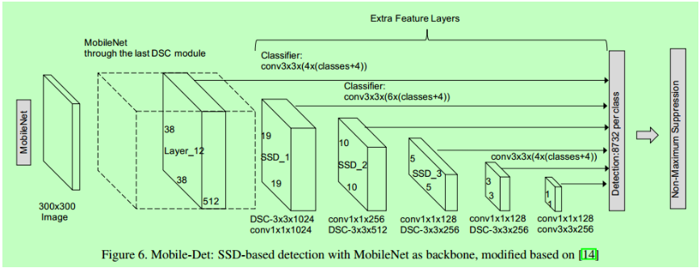

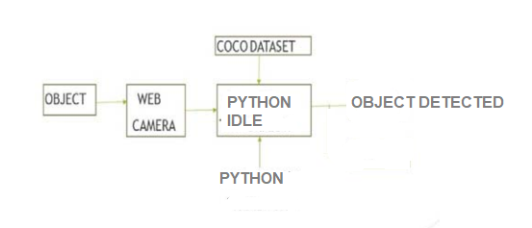

**Software used**

**Python idle**

Python is a high level, interactive, interpreted and item-oriented language for scripting. It is designed to be tremendously readable. Also it makes use of English key expressions often as languages use punctuations, and it has less syntactical block than the other programming languages.

The leap forward and speedy taking on of deep studying in Python introduced into life elegant and super accuracy in item detection codes and techniques cherish R-CNN, Fast-RCNN, Faster-RCNN, tissue layer net and short despite the fact that tremendously correct ones like SSD and YOLO. Victimisation of those strategies and algorithms supported by deep studying. This is moreover primarily based totally on system studying, mathematical and deep studying frameworks know-how is hired in our task for item detection.

**Packages used**

**Python OpenCV**

Python OpenCV consist of collection of programming functions which aims at working on laptop real time vision, OpenCV is an ASCII text file library for computer vision related applications such as CCTV analysis. It is not a tool that is not capable of processing images and executing computer vision related job. OpenCV is coded in C++ programming language and has 2,500+ optimised codes. [5] With the aim that once we create applications related to system vision that we do not need to develop from scratch, we can use these library functions to start specialising in planetary problems. OpenCV has a video browsing function i.e., cv2.VideoCapture (). We can control digital cameras by passing zero as a value to the function parameter. For CCTV recording, we can pass the RTSP computer address into the function parameter, which is very useful for video observation and analysis.

Python numpy, Coco dataset, Python imutlis are the other packages used for the dataset of objects and also for the text voice generation. Python text to speech function is used for detection of the object and giving a voice generation alarm.

Chapter 4

**Working principle of your project**

SSD can be a popular algorithmic code in object recognition. This is usually faster than the faster RCNN. We tend to deploy a MobilenetV2 SSD trained on the victim of an idle Python coconut tree dataset. In this project, we will detect any of the categories of item given by the coconut tree dataset. Input is provided via camera or real-time webcam video, supporting efficient mobile internet design that uses deep separable complexes to develop lightweight deep neural network. The feed in video is sorted into different parts, different frames and passed into the Cell Network layers. [4] Each characteristic value is defined as the importance between the amounts of component strength under the highlight and thus the component intensity is under the dark area. All possible sizes and areas of images are used to develop these elements. an image can contain orthogonal options and some related features that would normally observe the item. The main work of the mobile internet layer is to convert the pixels of the feed-in portrayal into the highlights that describes the content of the portrayal. It then switches to the Mobile NetSSD model to see the bounding rectangle and to its related object categories (labels) and then the only last procedure is to view or display the output. When the object is recognised from the given dataset, a voice alarm will be generated to provide information about the detected object.

**Results and inference made from results**

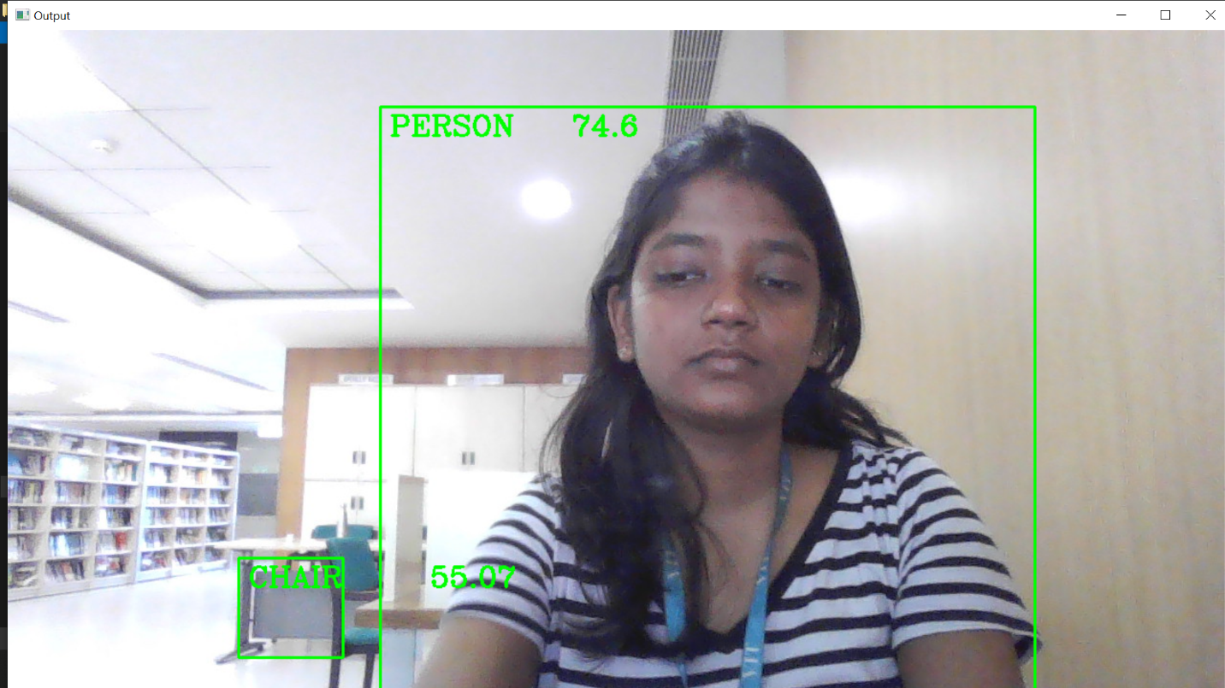

**Object Detection using Mobile net SSD**

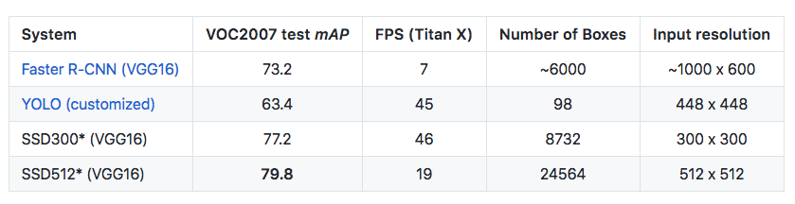

Thus, the software successfully detects, animate and inanimate objects with an approximate accuracy of 95%. Also in the above table the comparison between the various methods is showcased to prove the efficiency and importance of SSD mobilenet method.

**Chapter 5**

**Conclusion and Future Scope**

By the use of this approach and experimental outcomes we had been able to detect the object to the everyday accuracy like different excellent in magnificence frameworks. Also in this course of action, we make use of an item detection module that may apprehend what's inside the actual time video stream. To perform the procedure, we are part of the Mobile Net and the SSD framework for a fast and effective deep getting to know-primarily based totally approach for item detection. In destiny work, we are able maximum accuracy. In this project, we proposed a deep knowledge getting to know version to perceive regularly the vicinity of the item in pictures. And the framework may want to differentiate the object with to hold on improving our detection community version, along with reducing reminiscence usage and rushing up and moreover we are able to upload greater classes. The destiny enhancement of our task may be used for facial reputation in an effort to take the attendance inside the college to keep away from mal-practices, to come across the motion of the eyes at the same time as riding in an effort to make certain that the motive force isn't always snoozing to save you the injuries with the aid of using alerting the motive force with the support of using vibrating or with the aid of using a few sound alerts, it could be used to calculate the gap among automobiles for parking the car with the aid of using speech alerts, and so on.

**References:**

* [https://medium.com/axinc-ai/mobilenetssd-a-machine-learning-model-for-fast-object-detection-37352ce6da7d#:~:text=MobilenetSSD%20is%20an%20object%20detection,detection%20optimized%20for%20mobile%20devices](https://medium.com/axinc-ai/mobilenetssd-a-machine-learning-model-for-fast-object-detection-37352ce6da7d).
* <https://towardsdatascience.com/custom-object-detection-using-tensorflow-from-scratch-e61da2e10087>
* Yundong Zhang, Haomin Peng haomin and Pan Hu, Towards Real- time Detection and Camera Triggering, CS341.
* Ibai Gorordo Fernandez and Chikamune Wada, Shoe Detection Using SSD-MobileNet Architecture,2020 IEEE 2nd Global Conference on Life Sciences and Technologies (LifeTech 2020).
* Yu-Chen Chiu, Chi-Yi Tsai, Mind-Da Ruan, Guan-Yu Shen and Tsu- Tian Lee, Mobilenet-SSDv2: An Improved Object Detection Model for Embedded Systems, Â©2020 IEEE.
* Andres Heredia and Gabriel Barros-Gavilanes, Video processing inside embedded devices using SSD-Mobilenet to count mobility actors, 978- 1-7281-1614-3/19 Â©2019 IEEE.
* G. Bradski and, A. Kaehler, Learning OpenCV, OReilly Publications, 2008.
* Animesh Srivastava1, Anuj Dalvi2, Cyrus Britto3, Harshit Rai4, Kavita Shelke5, Explicit Content Detection using Faster R-CNN and SSD MobileNet v2, e-ISSN: 2395-0056 Â© 2020, IRJET.
* R. Huang, J. Pedoeem, and C. Chen, YOLO-LITE: A Real-Time Object Detection Algorithm Optimized for Non-GPU Computers, in Proceedings – 2018 IEEE International Conference on Big Data, Big Data 2018

**----------------------------------------------------------**